**subscribers galore: exoloring world’s top youtube channels**

**Project BasedExperiential Learninng Program**

1. **Introduction:**
   1. **Overview:**

A subscriber to a channel on the video-sharing YouTube is a user who has chosen to receive the channel's content by clicking on that channel's "Subscribe" button, and each user's subscription feed consists of videos published by channels to which the user is subscribed. The ability to subscribe to users was introduced in October 2005. YouTube began publishing a list of its most- subscribed channels in April 2006. An early archive of the list dates to May 2006.

The following table lists the 50 most-subscribed YouTube channels, as well as the primary language and content category of each channel. The channels are ordered by number of subscribers; those whose displayed subscriber counts are identical are listed so that the channel whose current growth rate

* 1. **purpose:**

To create visualization to understand and explore the information. The goal of visualization is to make complex data sets more accessible, and easier to interpret. By using visual element such as graph, charts and maps. Using the visualization to create the dashboard and story. People understand the data quickly and currectly. Gathering the data and connect the data to tableau. Create the visualizations, dashboard and story. Visualization is a cognitive process that allows to form a mental image to gain insights, discover, make decisions and explain. Make it easier to identify patterns, trends and outliers in large data sets.

1. **Problem Definition and Design Thinking**
   1. **Empathy Map:**

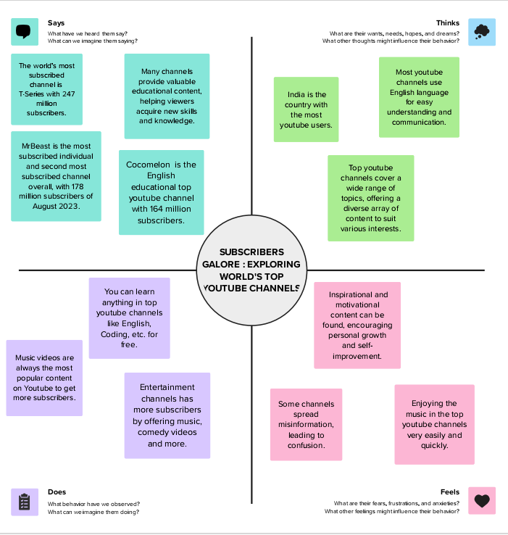

<https://app.mural.co/t/subscribersgaloreexploringwo9044/m/subscribersgaloreexploringwo9044/1693724494841/03e1f102de424ed1870a5c05458e69dffe2e4963>

**2.2 Ideation and Brainstroming Map:**

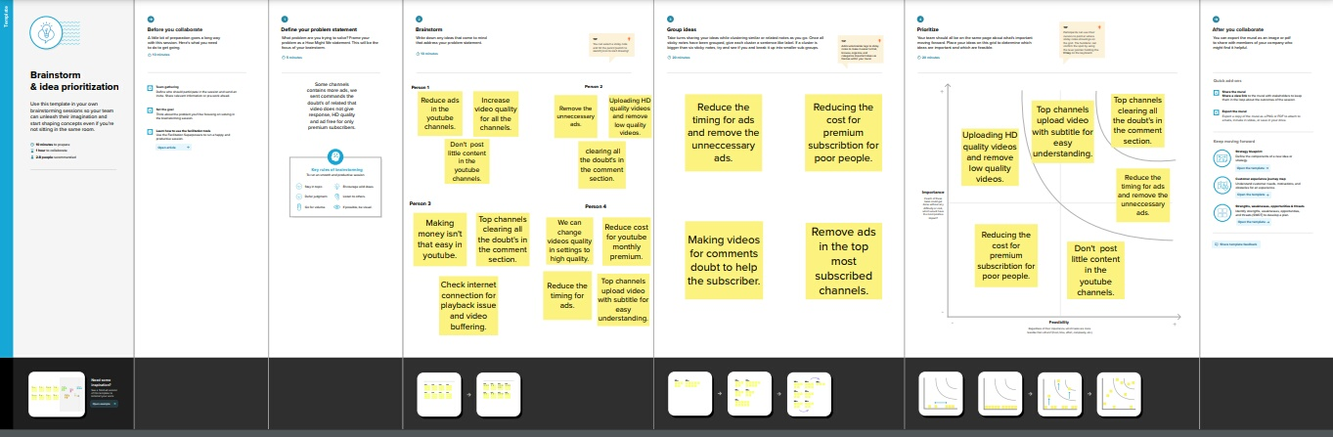

<https://app.mural.co/t/subscribersgaloreexploringwo9044/m/subscribersgaloreexploringwo9044/1693839531232/8ddf70be5800eff9a5a39dedabffd11ae49a3cd4>

Activity and screenshot:

**1. Open tableau desktop:**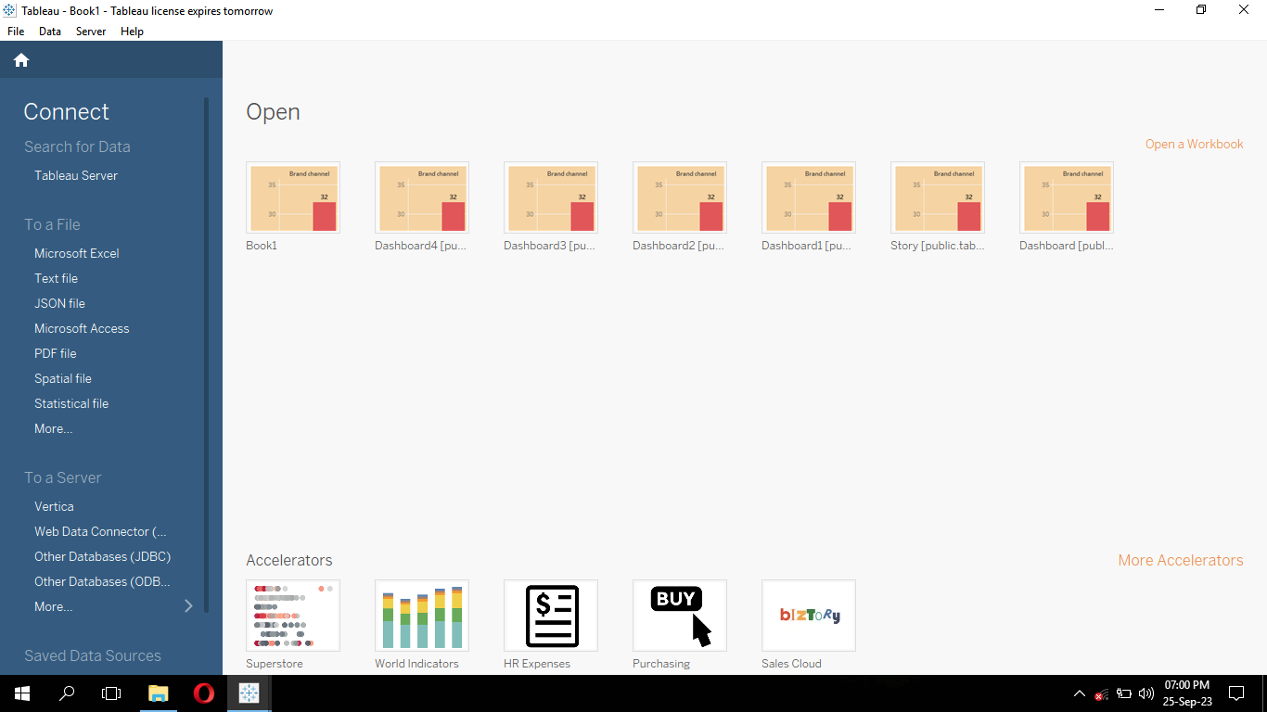

* Open the tableau desktop app.

**2. Connect the data set:**

* Connect the data set by clicking the text file in the connect menu.
* Select the data file and click open.
* List of most subscribed youtube channel table is shown.
* We will see the data set that contains 50 rows and 9 columns.

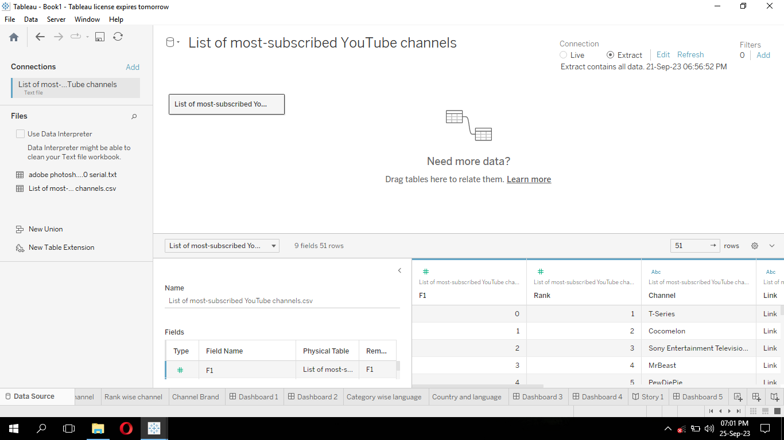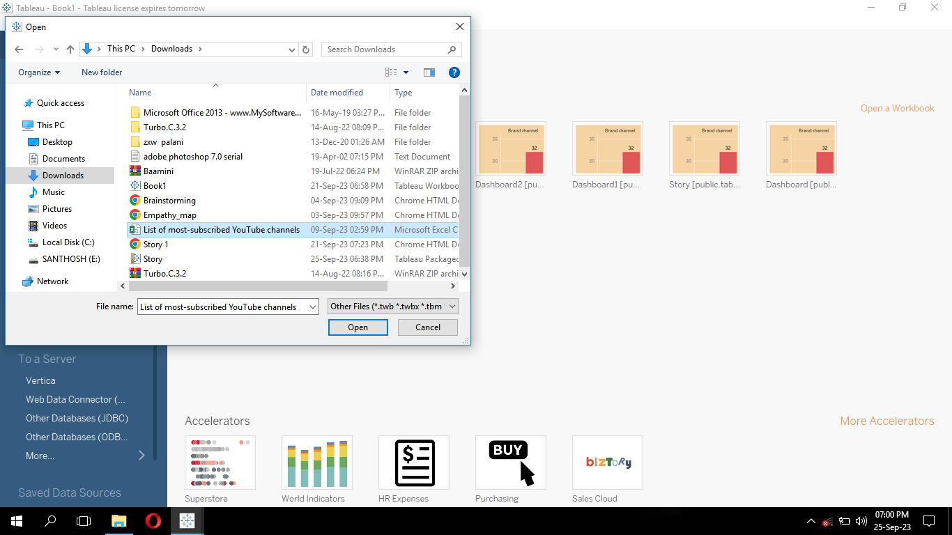

1. **No of channel with brand:**

* Open the new sheet. In the left side we will see Tables. In the Tables drag the Brand channel in the columns and drag Rank in the row.
* Right clicking the rank in the row click measure to change count. We will see CNT(rank) in row. It is count of rank.
* Drag Brand channel in colour and count of rank in label.
* If we want change background color by clicking format 🡪 worksheet 🡪 shading. Choose color.
* Name the sheet as “No of channels with brand”. Filter the unwanted data.

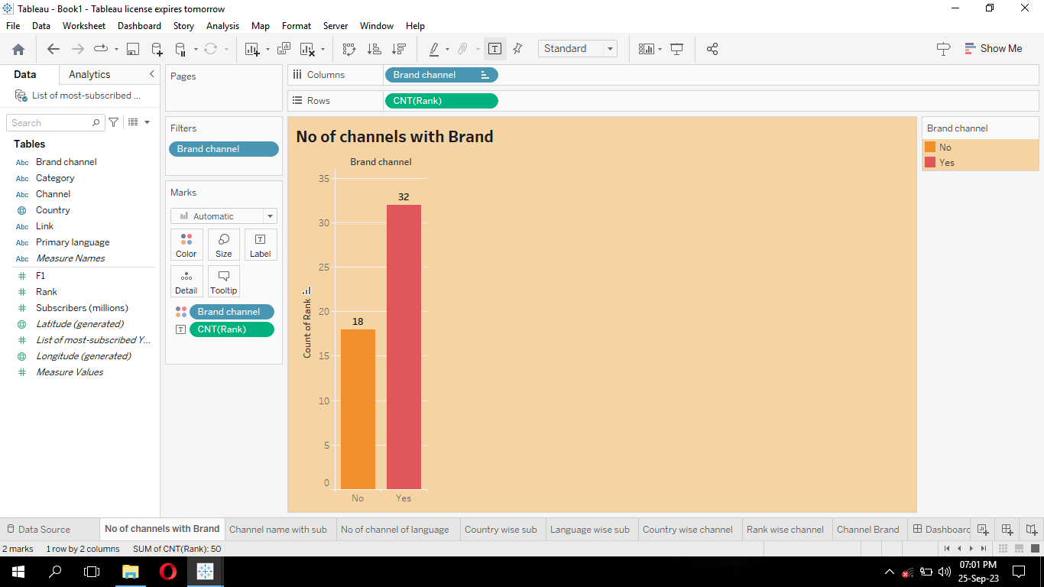

1. **Channel name with subscribers:**

* Add new sheet.
* Drag the subscribers to the size.
* Right click the subscribers. In the pop up menu click measure and change the measure to SUM.
* We will see the subscribers in the size will be changed to SUM(subscribers).
* Similarly drag the SUM(subscribers) to the color.
* Drag the channel to label. We will see the channel name in the heat map.
* Name the sheet as “Channel name with subscribers”.

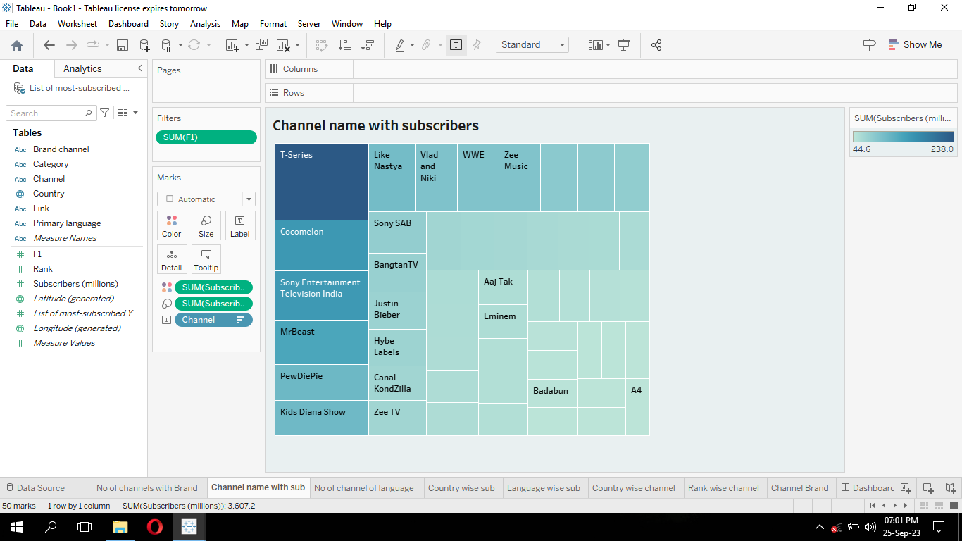

1. **No of channels of a primary language:**

* Add new sheet. Drag primary language to color, size, detail, label.
* Change the measure to count for primary languages in the size and detail.

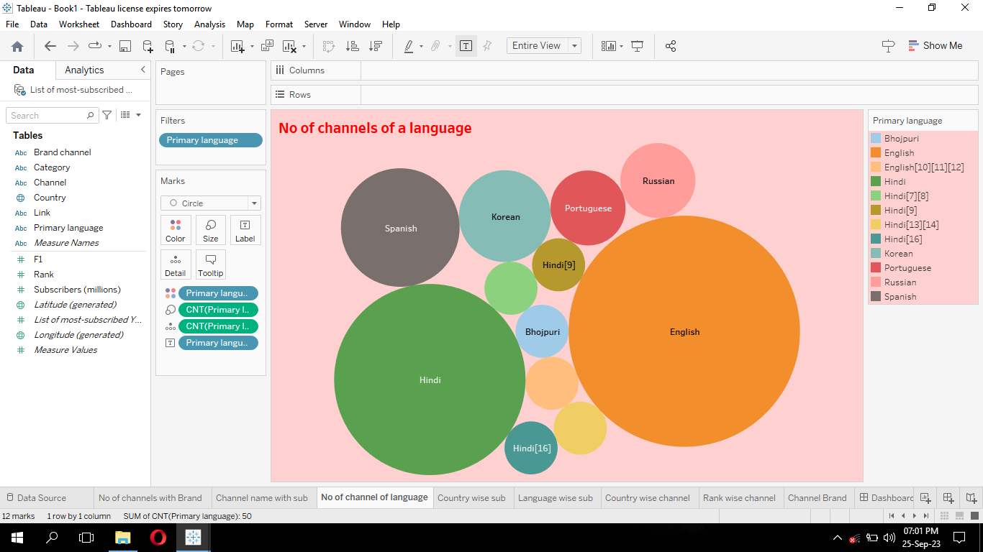

* Name the sheet as “No of channels of language”.

1. **Country wise subscribers:**

* Add new sheet. In the table drag country to columns.
* Drag subscribers to rows. Right click the subscribers in the pop up menu click measure and select SUM. It shows sum of subscribers.
* Drag country to color.
* If we want change background color by clicking format 🡪 worksheet 🡪 shading. Choose color.
* Name the sheet as “country wise subscribers”.

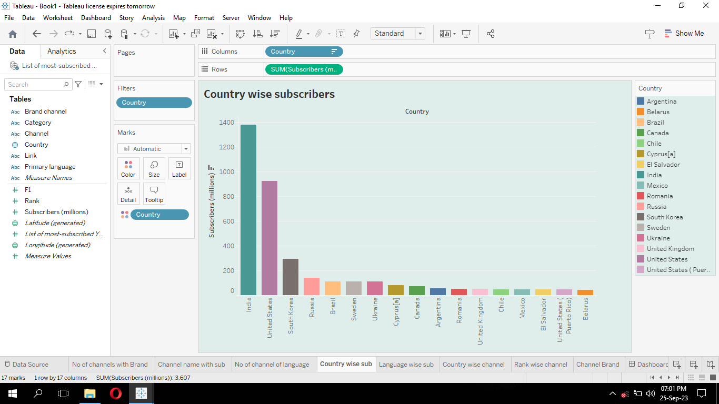

1. **Language wise subscribers:**

* Add new sheet and drag primary language to columns.
* Drag subscribers to rows and change the measure to sum by right clicking the subscribers in the pop up menu click measure and select sum. It refer sum of the subscribers.
* Also drag primary language to color and drag the sum of subscribers to label. If we want change background color by clicking format 🡪 worksheet 🡪 shading. Choose color.
* Name the sheet as “Language wise subscribers”.

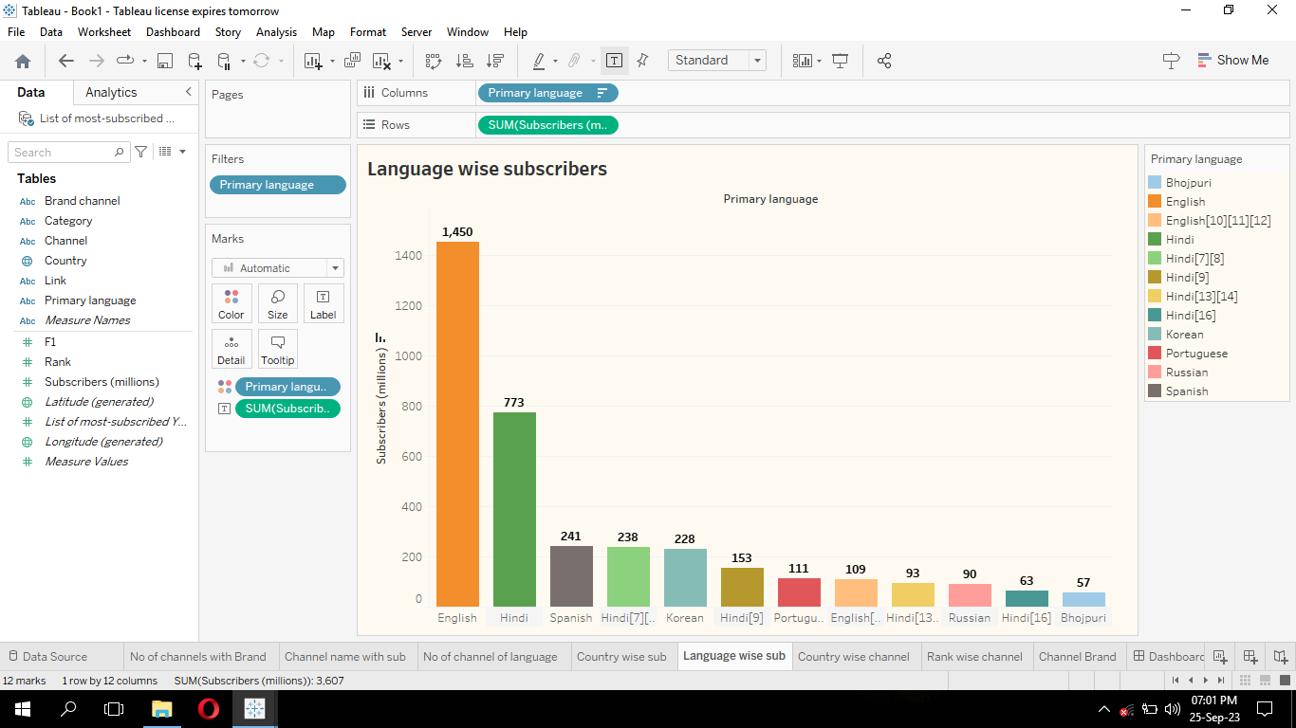

1. **Country wise channel:**

* Add new sheet. Drag country to columns and select map in show me.
* Drag country to color, label, detail.
* Drag primary language to detail.
* Drag channel to detail and right click in the sub menu click measure and select count.
* Name the sheet as “Country wise channel”.

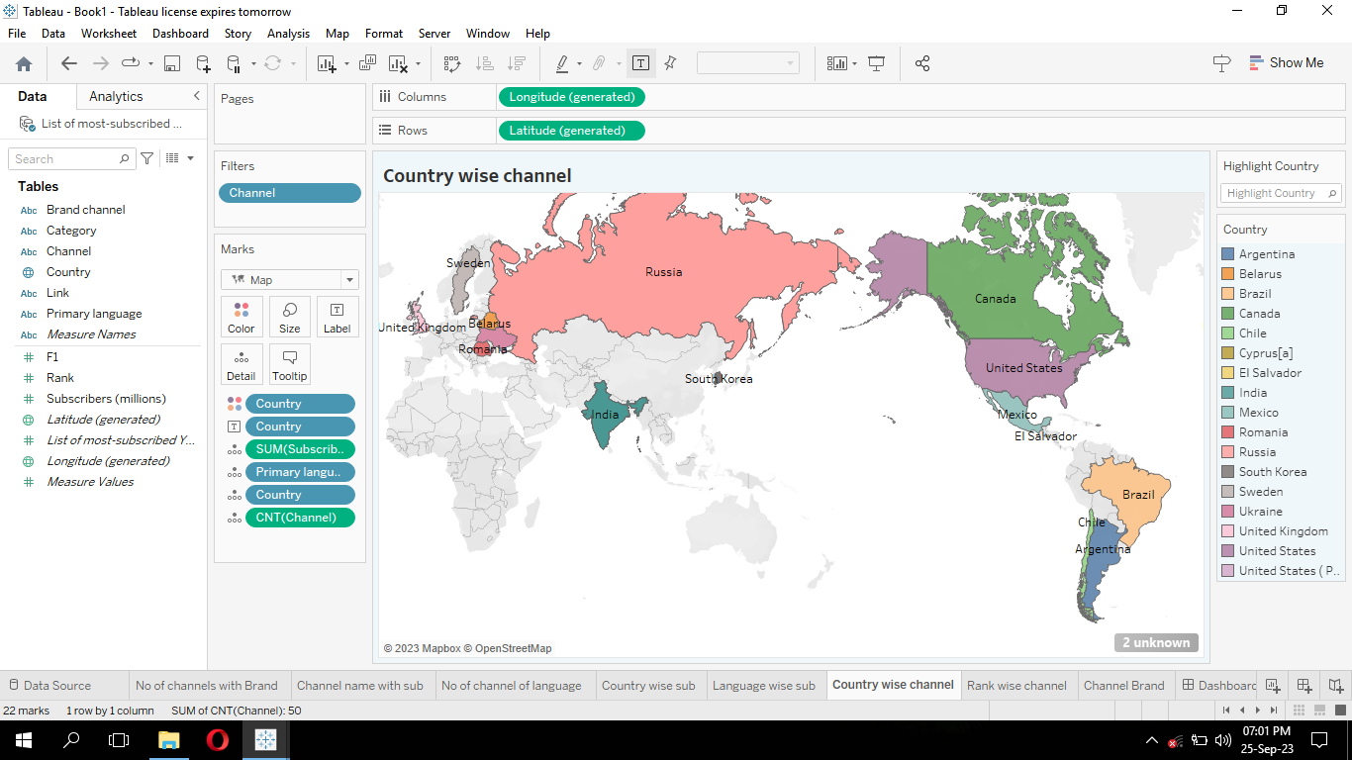

1. **Rank wise channel:**

* Add new sheet. Drag channel to rows and drag rank to label.
* Change the measure of rank to sum. Change to ascending order.
* Name the sheet as “Rank wise channel”.

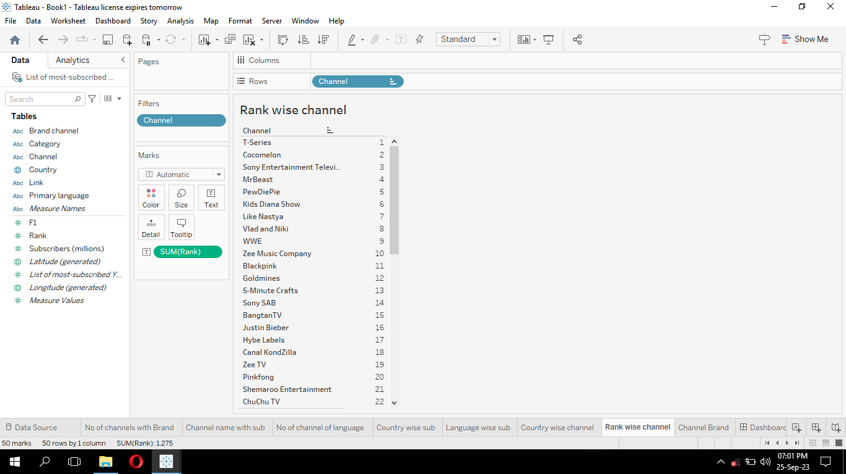

**10. Channel Brand:**

* Add new sheet. Drag channel to rows and drag brand channel to columns.
* Also drag brand channel to color and text. We will get the visualization.
* Name the sheet as “Channel brand”.

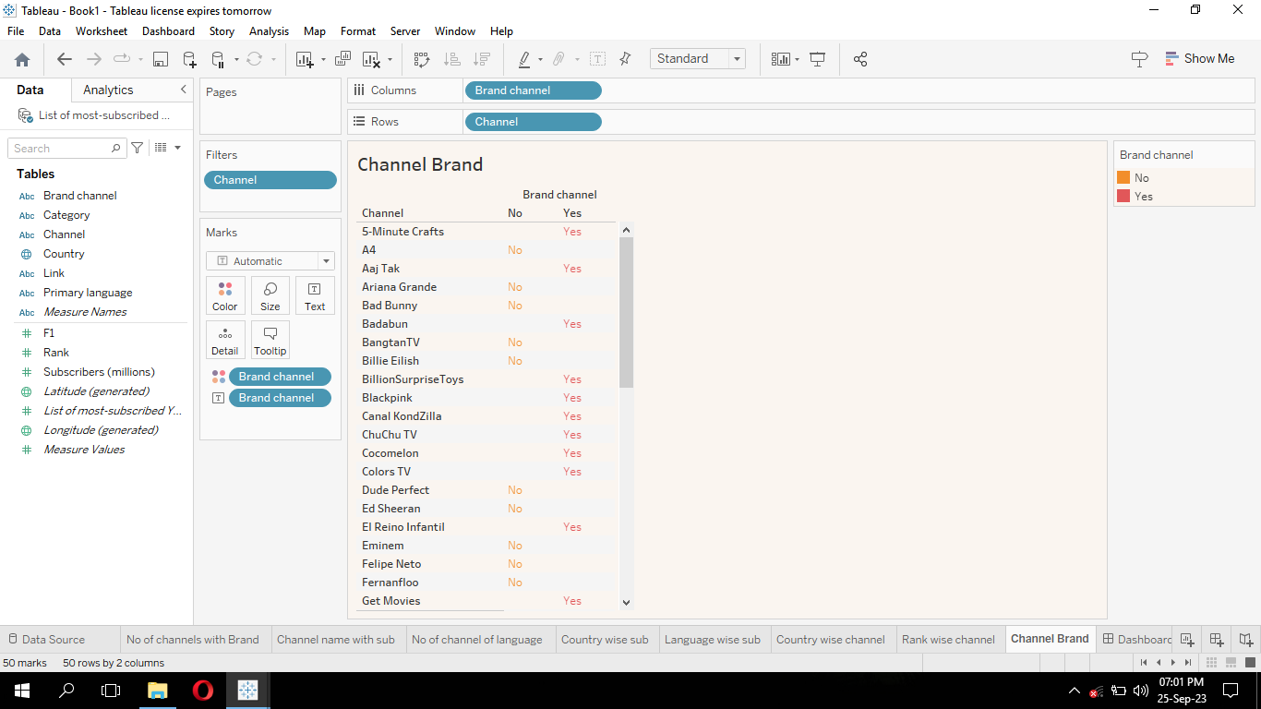

**11. Category wise language:**

* Add new sheet. Drag primary language to rows. Drag subscribers to column with the measure sum.
* Drag category to color and detail.
* Drag subscribers to label and right click in the sub menu click measure and select sum.
* If we want change background color by clicking format 🡪 worksheet 🡪 shading. Choose color.
* Name the sheet as “Category wise language”.

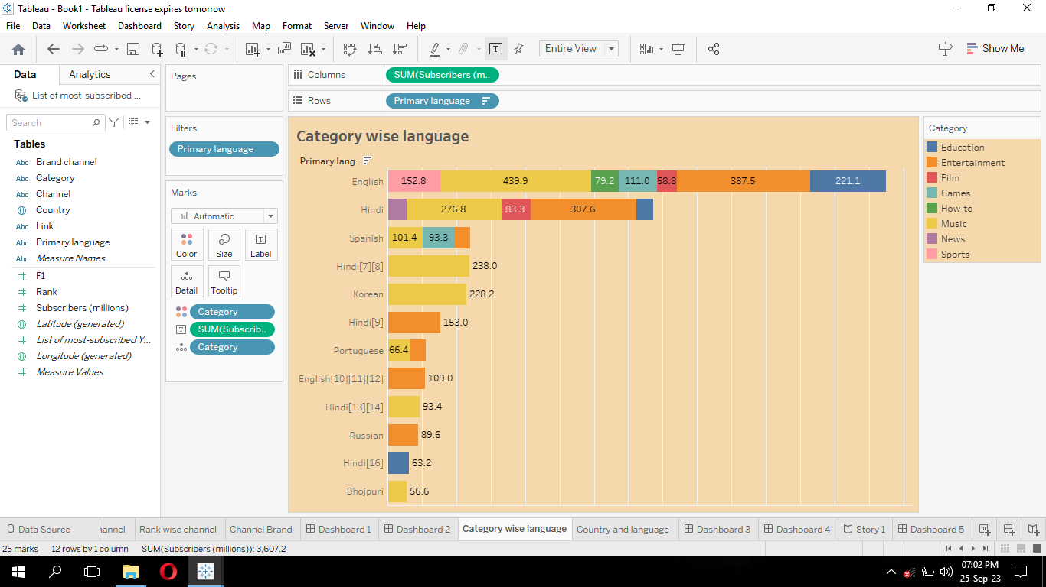

**12. Country and language:**

* Add new sheet. Drag primary language and country to columns.
* Drag subscribers to row. Right click the subscribers in row click measure and select measure as sum.
* Drag the country to color.
* If we want change background color by clicking format 🡪 worksheet 🡪 shading. Choose color.
* Name the sheet as “Country and language”.

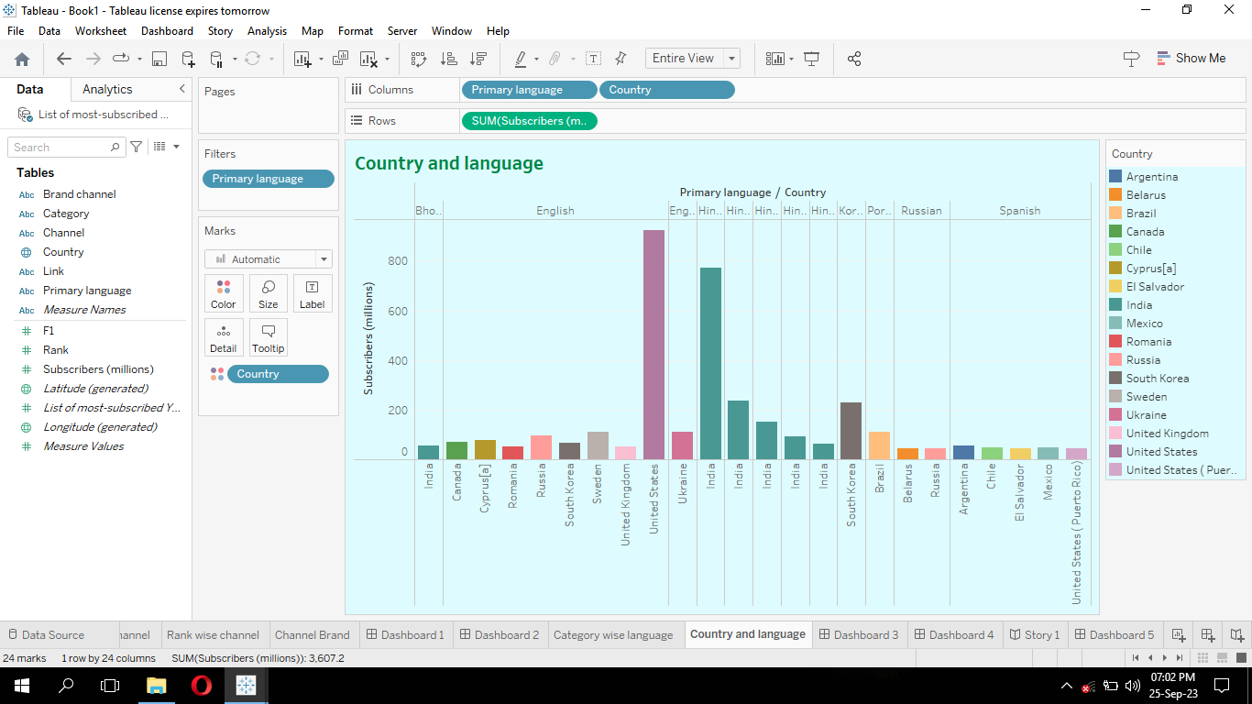

**Creating Dashboards:**

**Dashboard 1:**

* Add a new dashboard.
* In the left side we will see the sheets.
* Dashboard 1 is created by dragging the 3 sheets.
* Drag Rank wise channel, No of channel with brand, channel brand sheets to the dashboard.

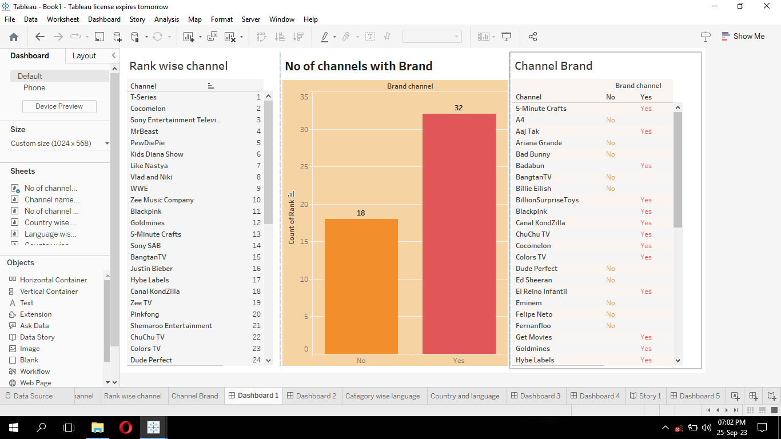

**Dashboard 2:**

* Add new dashboard.
* Drag channel name with subscribers and no of channels of a language sheets to the dashboard.
* Click the sheet. In the top right side click options and click highlight channel.
* Highlight the primary language in the no of channels of language sheet.

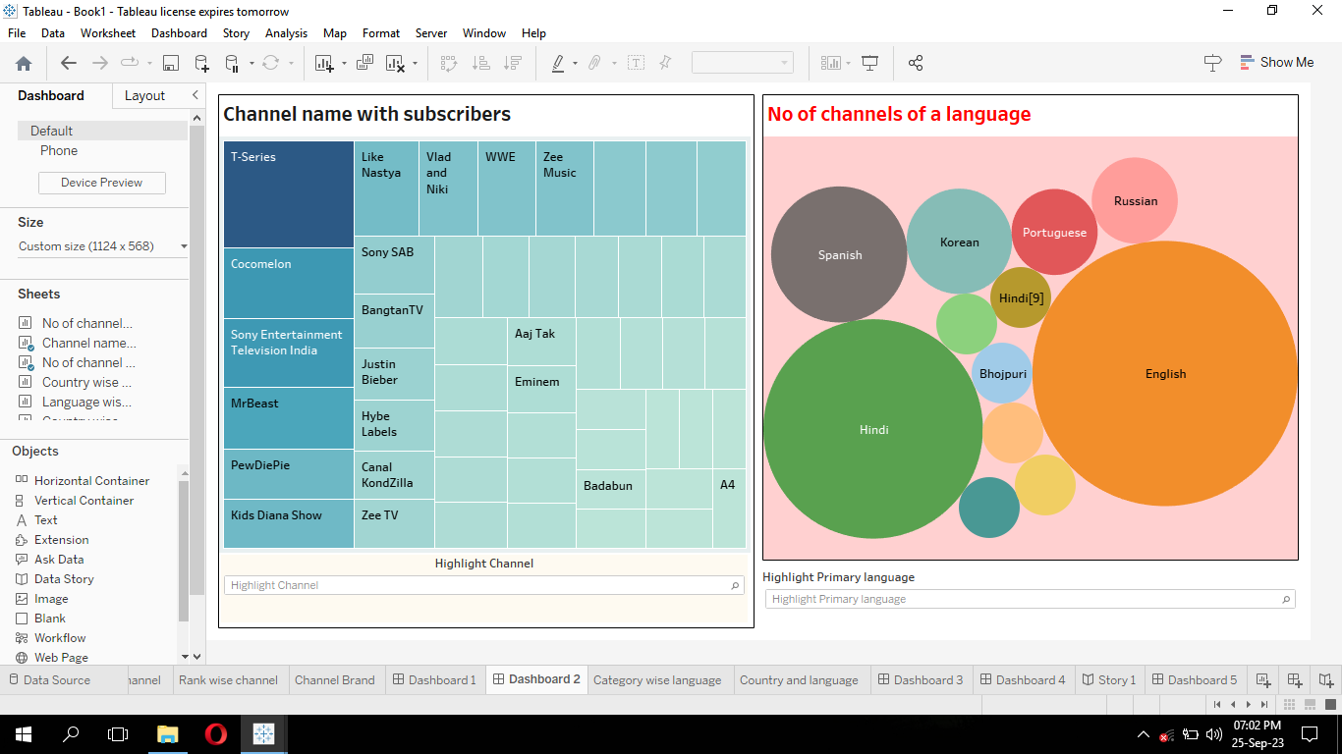

**Dashboard 3:**

* Add new dashboard. Drag the category wise language and country and language.

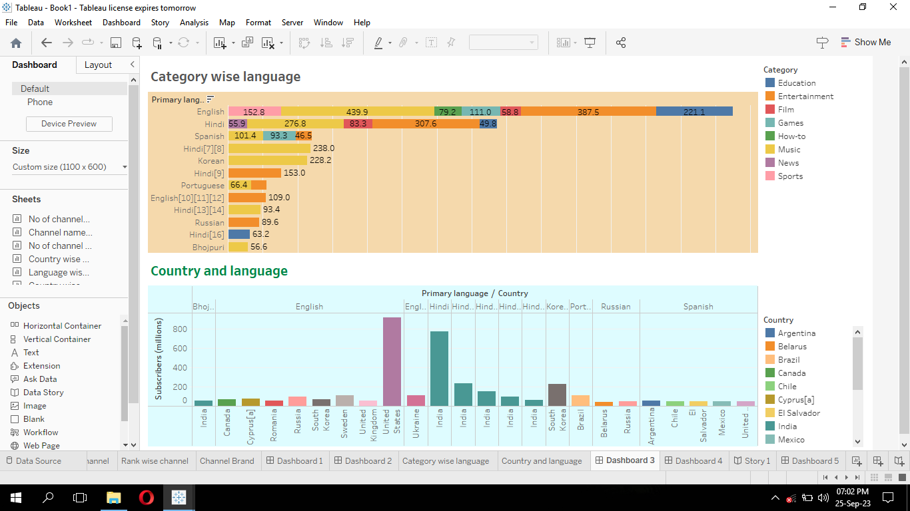

**Dashboard 4:**

* Add new dashboard. Drag the language wise subscribers sheet.
* Drag the country wise subscribers worksheet.

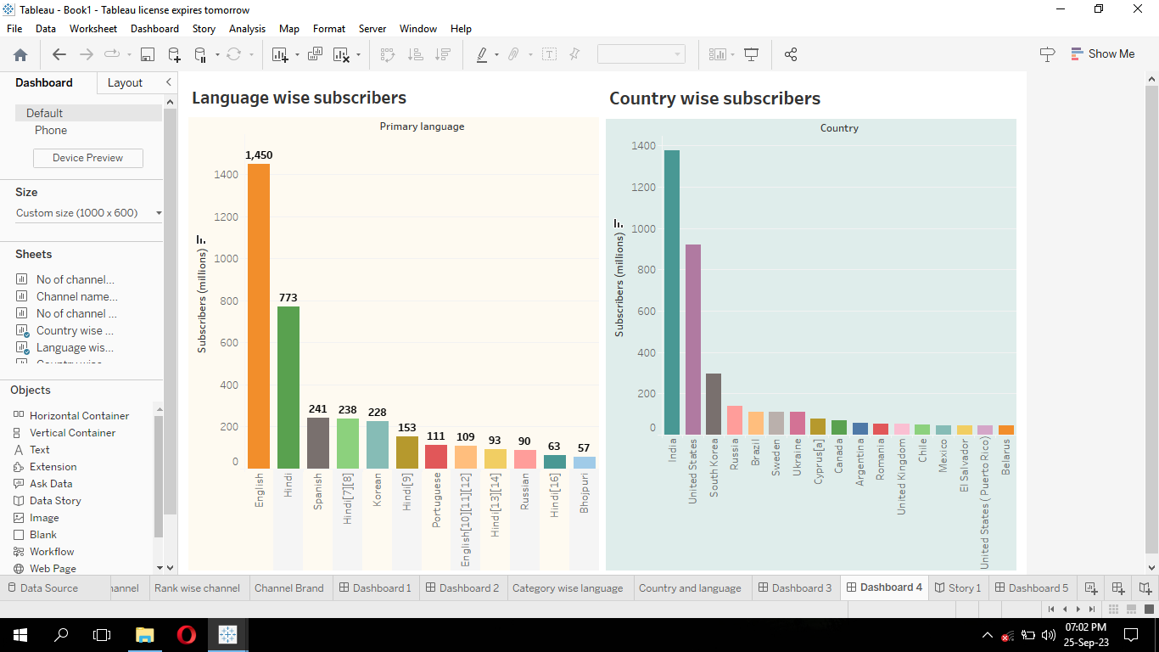

**Dashboard 5:**

* Add new dashboard.
* Drag the country wise channel worksheet to the dashboard.
* Highlight country by clicking options 🡪 highlight 🡪 country.

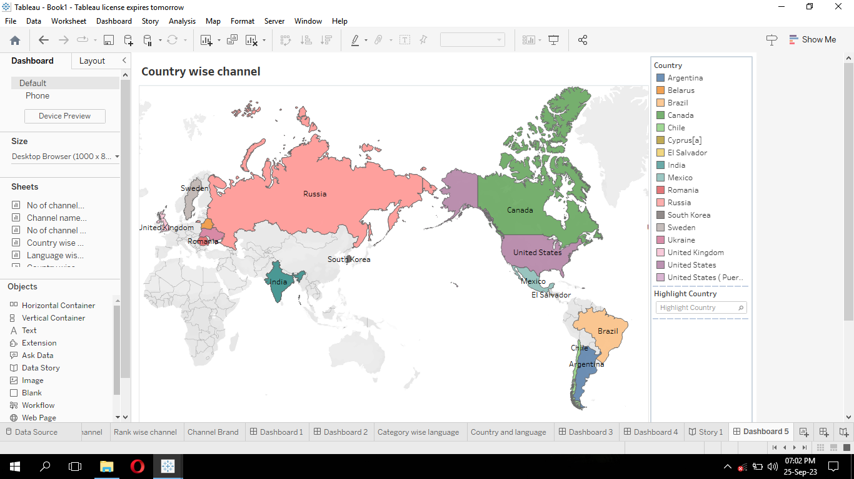

**Story:**

* Add a story. In the right hand side we will see all the sheets and dashboards.
* Drag the dashboard1. In the top rectangular box type channel details.
* In the right hand side we see new story point. Click blank. The new one is created.
* Drag the dashboard2. In the top rectangle box type ‘list of channels with no of subscribers and language.
* Again click blank in the new story point.
* Drag the dashboard3. In the top box type ‘Category wise language and country wish language’.
* In new story point click blank. The new one is created.
* Drag the dashboard4. In the box type ‘language and country wise subscribers’.
* In new story point click blank. The new story point is created.
* Drag dashboard 5. Type into the box ‘country wise primary language, number of subscribers and total number of subscribers’.

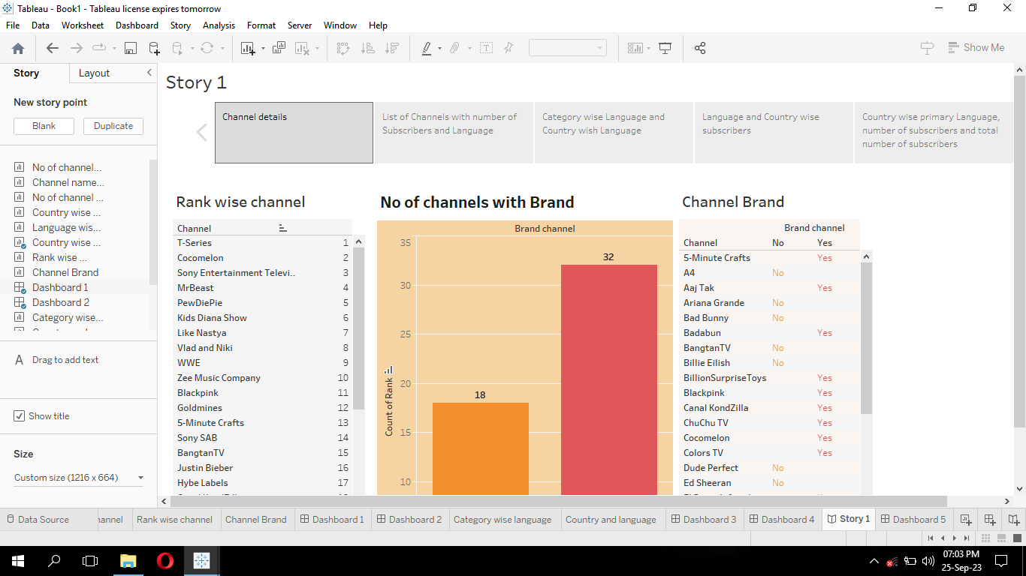

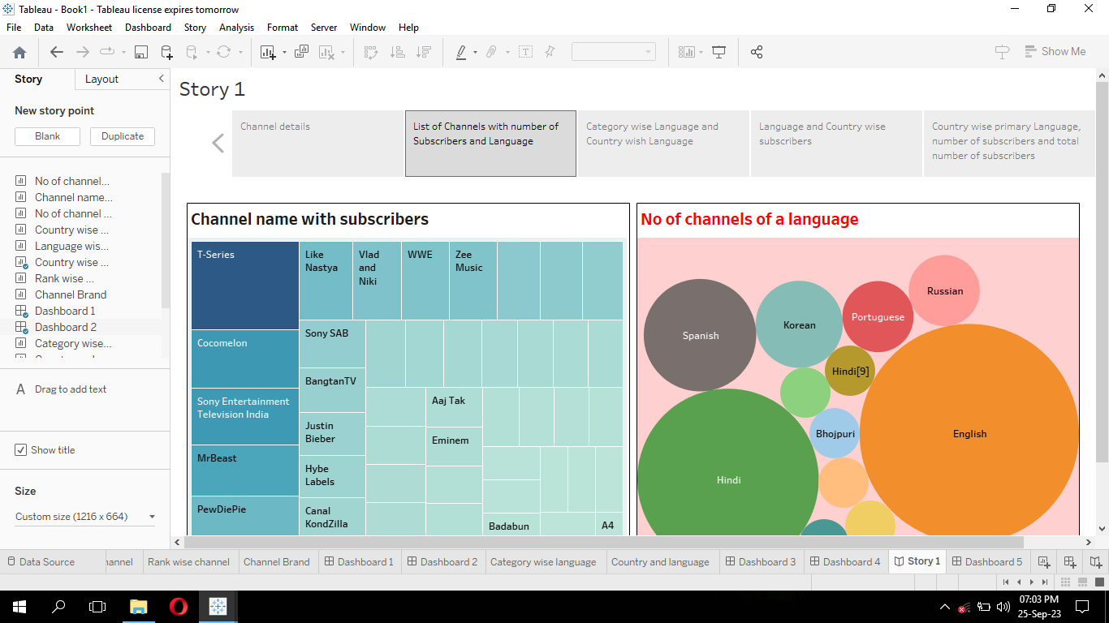

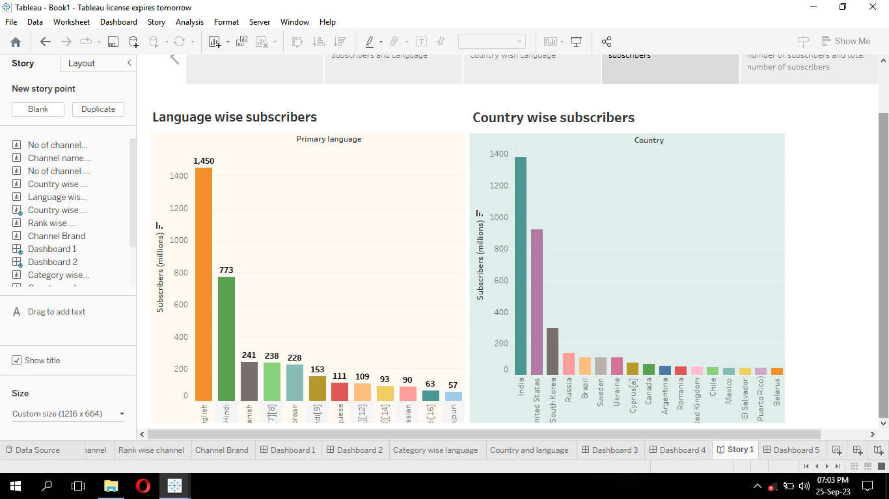

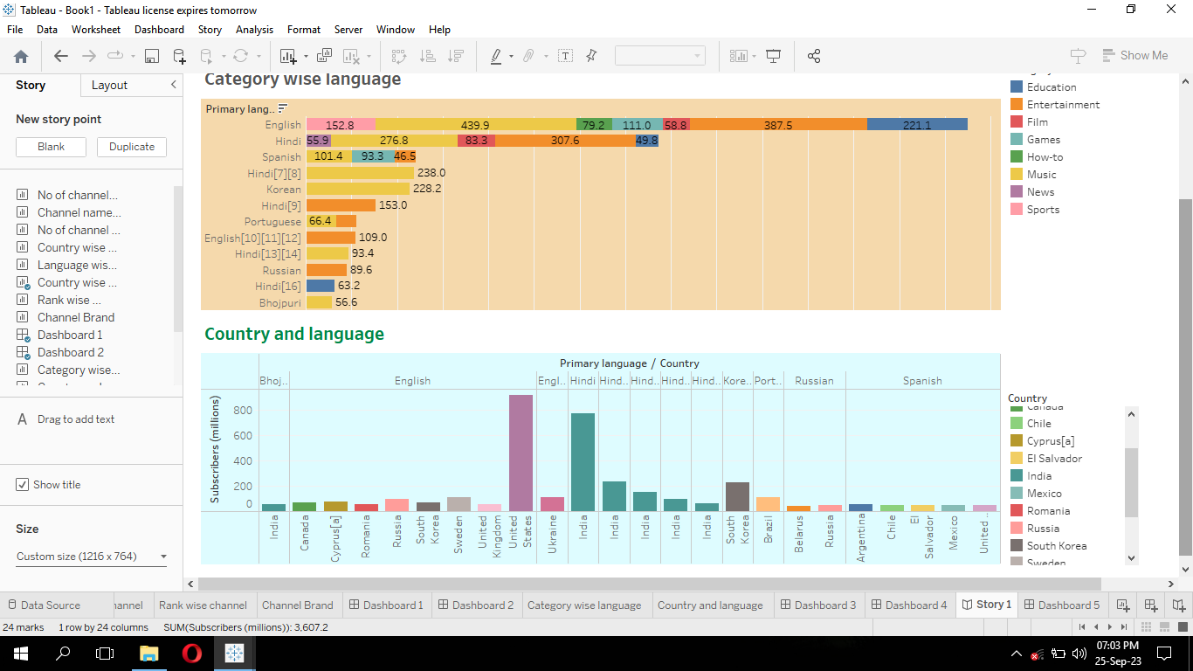

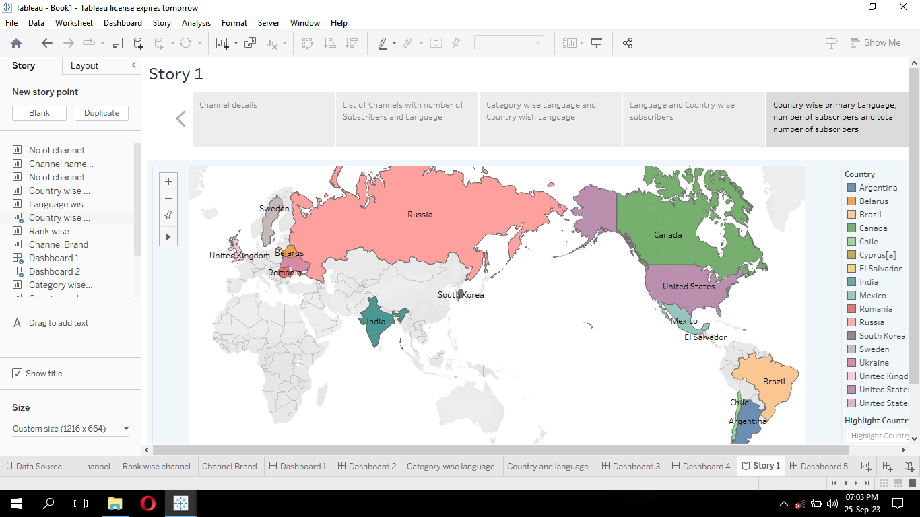

**Uploading the dashboard & story:**

* Go to data source and select extract so that .hyper extension files are created and save it at your desktop.



* Go to story, click on share button on the top.
* Give the server address of your tableau public account and click on connect.

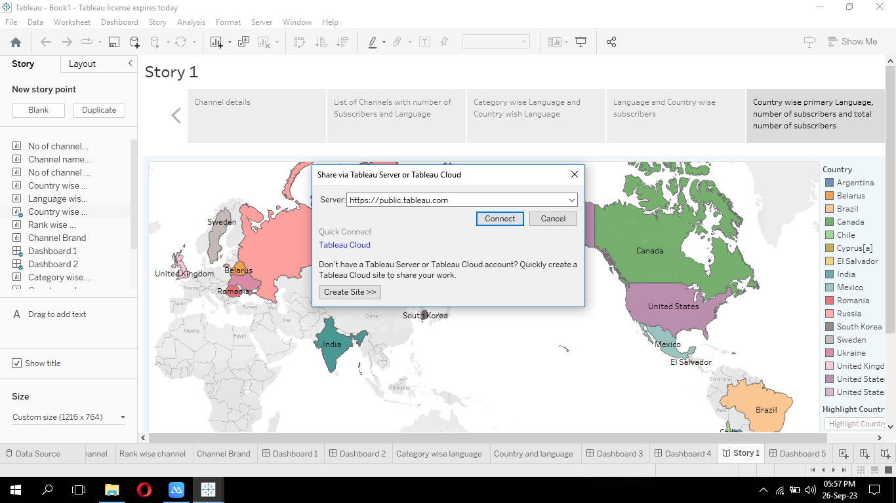

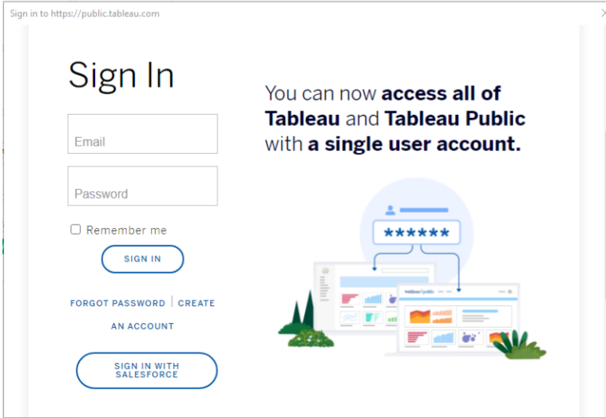

* Sign in to your tableau public account or create a new account if you don’t have one (or) create an account. You can visit the tableau public website (public.tableau.com) and click on the “sign in”.
* In the “Tableau public sign in” window, enter your tableau public account credentials and click “sign in”.
* Next, we will provide a title for the workbook. Fill in the appropriate details in the provided field of workbook title.

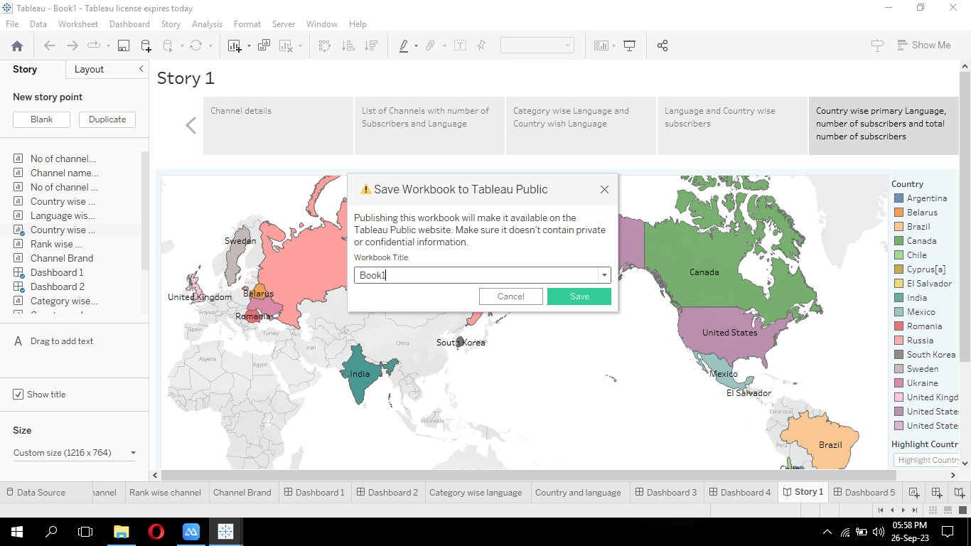

* Click “save” to start publishing process. Tableau desktop will upload workbook to tableau public.
* Once the upload is complete, a browser window will automatically open and displaying published workbook on tableau public.

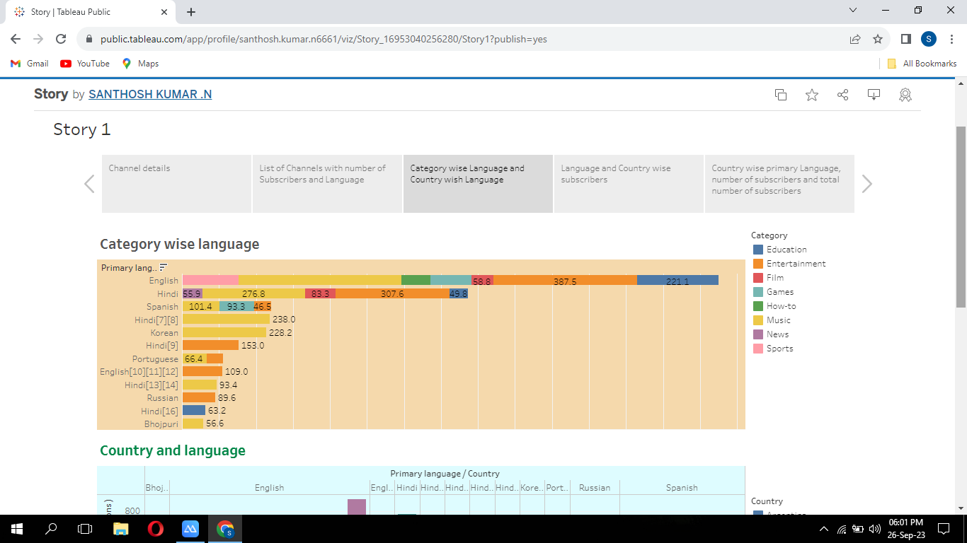

Similarly we can also publish dashboards to tableau public.

**Advantages:**

* Understand the data more quickly and easily.
* Better business decisions.
* Tableau can connect to live data sources, enabling real time data analysis and visualization.
* Quick insights help in identifying patterns.
* Sharing and collaboration: tableau server make it easy to share and collaborate.

**Disadvantages:**

* Understanding and managing tableau’s licensing options can be complex.
* Requiring more time, effort and skills to design.
* Develop and maintain than static charts.

**Conclusion:**

Table shows rank wise channel, bar graph shows the number of channels with brand, table shows brand, heatmap shows channel name with subscribers, circle shows a number of channels with a particular language, bar graph shows category wise language, bar graph shows the country with its primary language and no of subscriber and language wise subscribers, world map showing country wise channel. Dashboards are created using the visualizations. Also, story is created by dragging the dashboards.

**Future scope:**

Youtube has already experienced tremendous growth in recent years and this trend is expected to continue. With over 2 billion monthly active users and increasing video content. In recent years there has been a growing trend towards democratizing data visualization and making it more accessible.

**TABLEAU PUBLIC DASHBOARD URL:**

<https://public.tableau.com/views/Dashboard_16953035307510/Dashboard1?:language=en-US&:display_count=n&:origin=viz_share_link>

<https://public.tableau.com/views/Dashboard1_16953037014020/Dashboard2?:language=en-US&:display_count=n&:origin=viz_share_link>

<https://public.tableau.com/views/Dashboard2_16953046124100/Dashboard3?:language=en-US&:display_count=n&:origin=viz_share_link>

<https://public.tableau.com/views/Dashboard3_16953047275150/Dashboard4?:language=en-US&:display_count=n&:origin=viz_share_link>

<https://public.tableau.com/views/Dashboard4_16953048777270/Dashboard5?:language=en-US&:display_count=n&:origin=viz_share_link>

**TABLEAU PUBLIC STORY URL:**

<https://public.tableau.com/views/Story_16953040256280/Story1?:language=en-US&:display_count=n&:origin=viz_share_link>

**Tableau public profile URL:**

**Team Leader:** <https://public.tableau.com/app/profile/santhosh.kumar.n6661/vizzes>

**Team member 1:** <https://public.tableau.com/app/profile/saran.s6697/vizzes>

**Team member 2:** <https://public.tableau.com/app/profile/pravin.kumar.m3186/vizzes>

**Team member 3:** <https://public.tableau.com/app/profile/venkatesh.p5316/vizzes>

**Team member 4:** <https://public.tableau.com/app/profile/santhosh.m6692/vizzes>

**Demo video link:**

<https://drive.google.com/file/d/1Gu4uILeEHuyBEz-lSJyXn2x7OSGsb3Pf/view?usp=drivesdk>